Exercises: CSS Selectors and Rules—In depth

Recipe Card
You are given the HTML for the following Web page. Write the missing CSS:
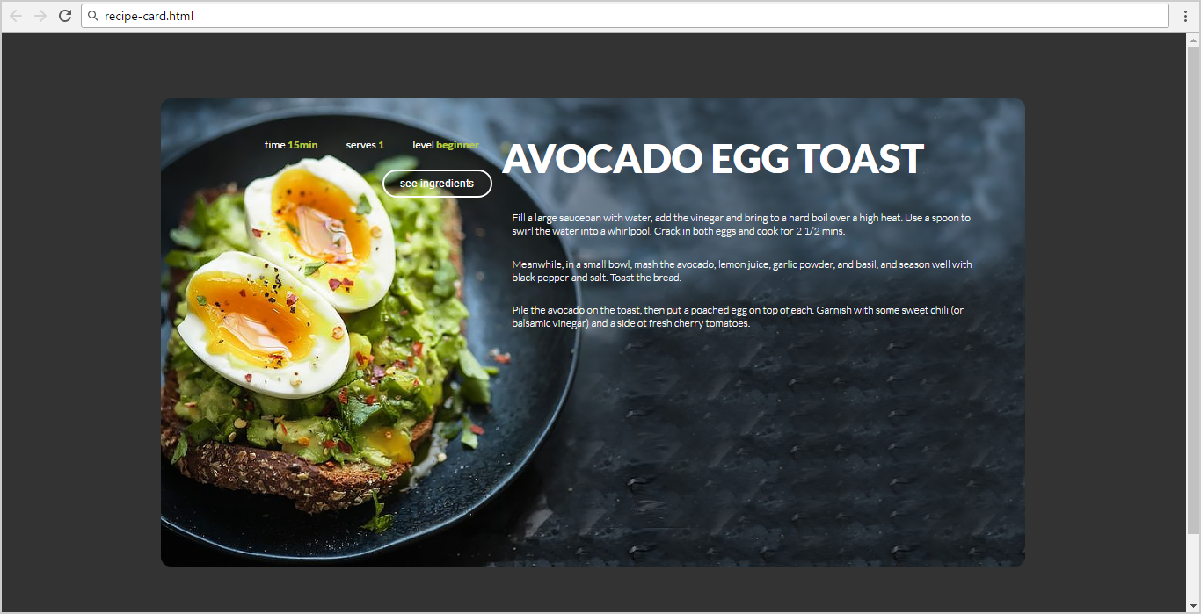
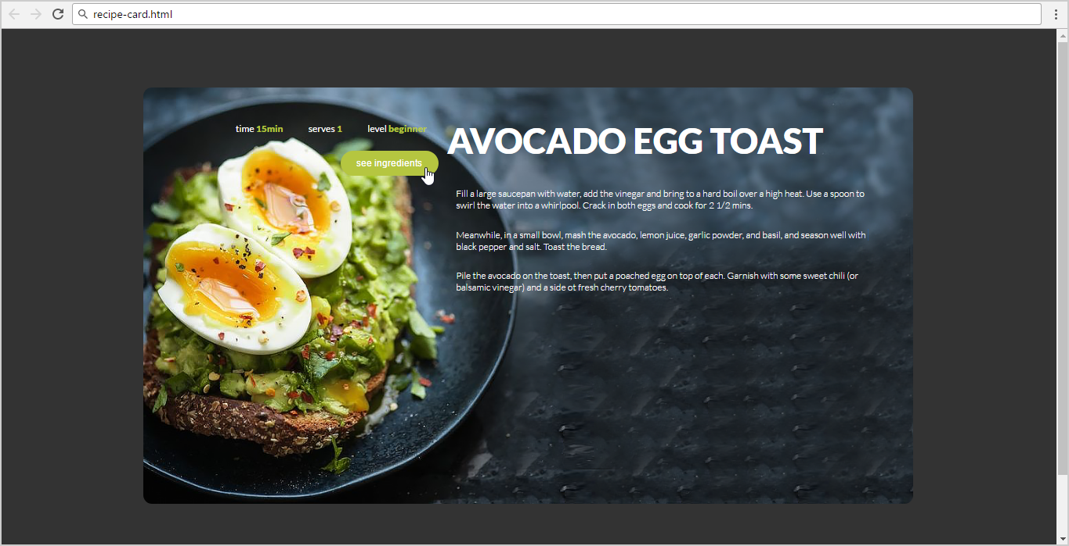
- Use the following HTML file as starting point: "recipe-card.html".
  - You are NOT allowed to change the HTML code.
- Create the CSS file: "recipe-card.css".

Constraints
- Default font: 16px font-family:"Lato", sans-serif;
"https://fonts.googleapis.com/css?family=Lato:300,400,900"
- Default text color: #ffffff
- Text-color: #b5c640

Hints
Use a color picker to catch certain colors.

Web Agency
You are given the HTML for the Web page shown below as screenshots. Write the missing CSS:



- Use the following file: "web-agency.html".
  - You are NOT allowed to change the HTML code.
- Create file: "web-agency.css".

Constraints
- As default font use “16px 'Lato', sans-serif”.
- Import the “Lato” font in your CSS from Google Fonts.
- As default color use “#333333”.

Potato
You are given the HTML for the following Web page. Write the missing CSS:
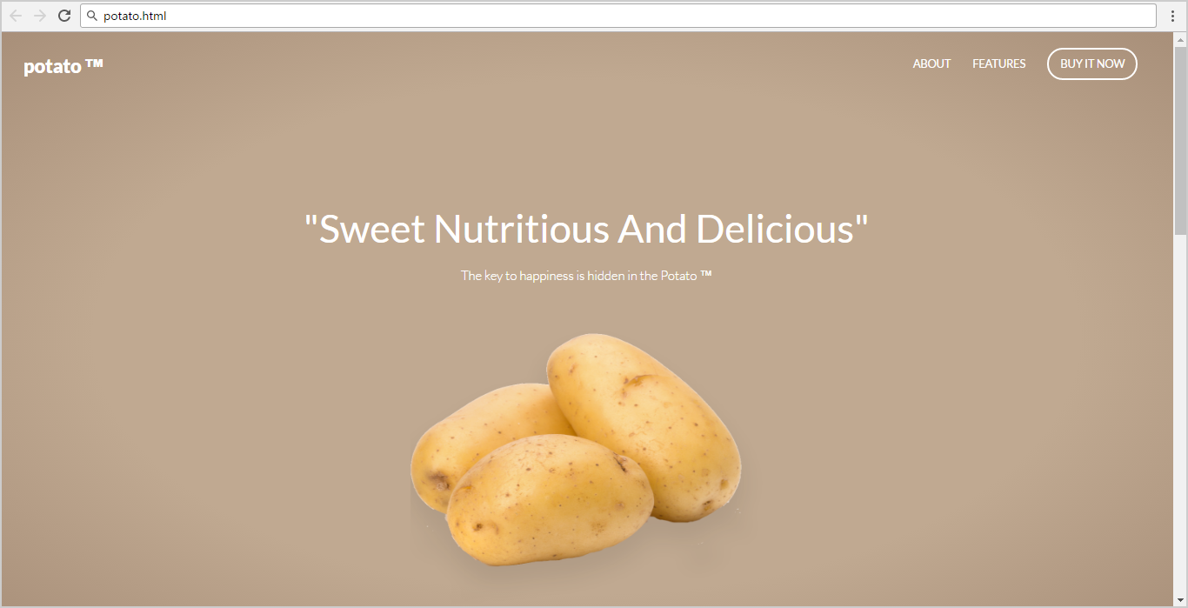
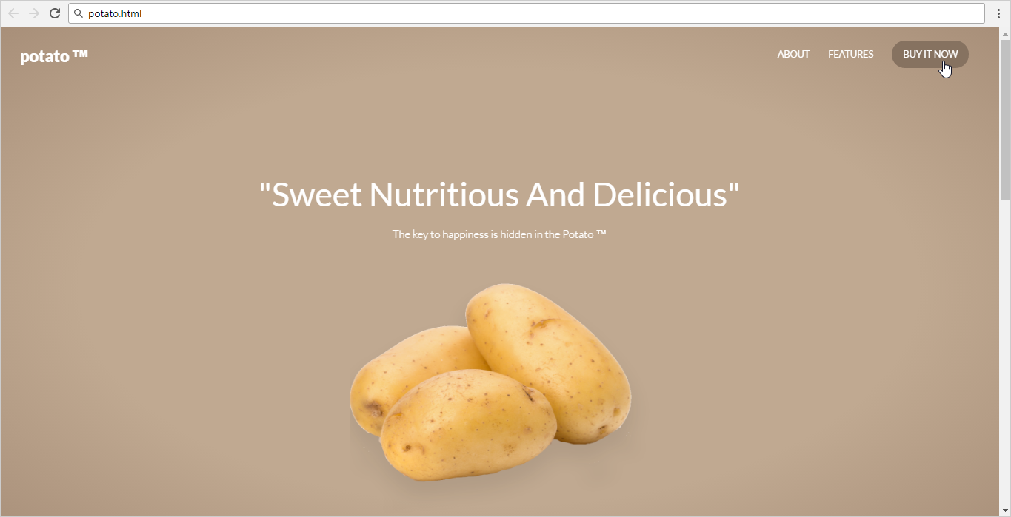
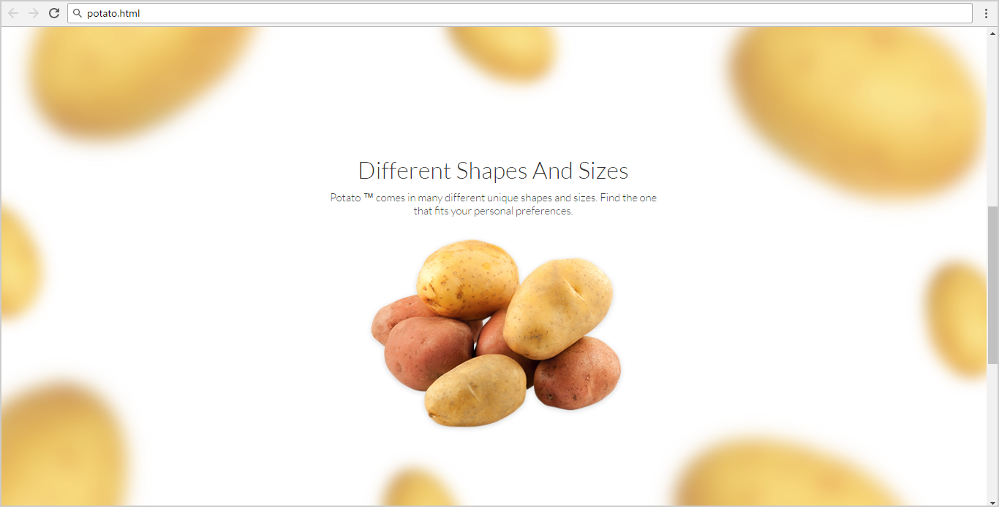

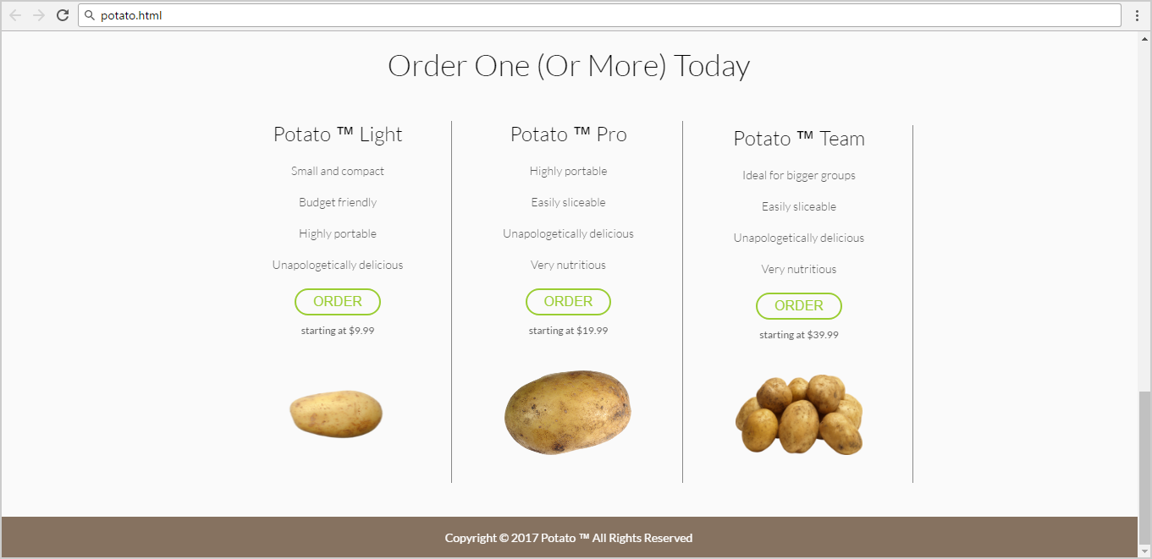
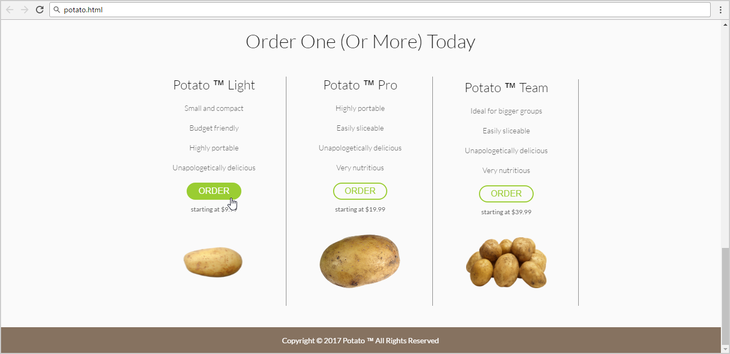
- Use the following HTML file as starting point: "potato.html".
  - You are NOT allowed to change the HTML code.
- Create the missing CSS file: "potato.css".

Constraints
- Default font: 14px 'Lato', sans-serif;

Hints
Use a color picker to catch certain colors.
Use for <header>
- background: radial-gradient(ellipse at center,
rgba(192,169,145,1) 0%,
rgba(192,169,145,1) 59%,
rgba(168,143,121,1) 100%);

